**Mainspring**

Key Resources to ask Mainspring PM access from ESA Project Manager

Checklist

* PM Plan to be green. It should be approved
* Monthly Metrics should be approved (First Project member should submit and then Prasad)
* Release metrics – Metrics Preview should be Green with less than 50% deviation which should be closed
* Critical Practices should be completed
* New Release to be created before the Month starts

**2 Days before Month End**

**First Activity**

Efforts to be repositioned

**Click on the number from Last Column(Adhoc Effort Available for apportioning)**

**For eg. Click on 220**

**Enter the 220 hours in CASS Maintenance Release and Save**

**Like wise, change for all the rows which has number>0 and assign it to the release.**

Complete the current Month Release.

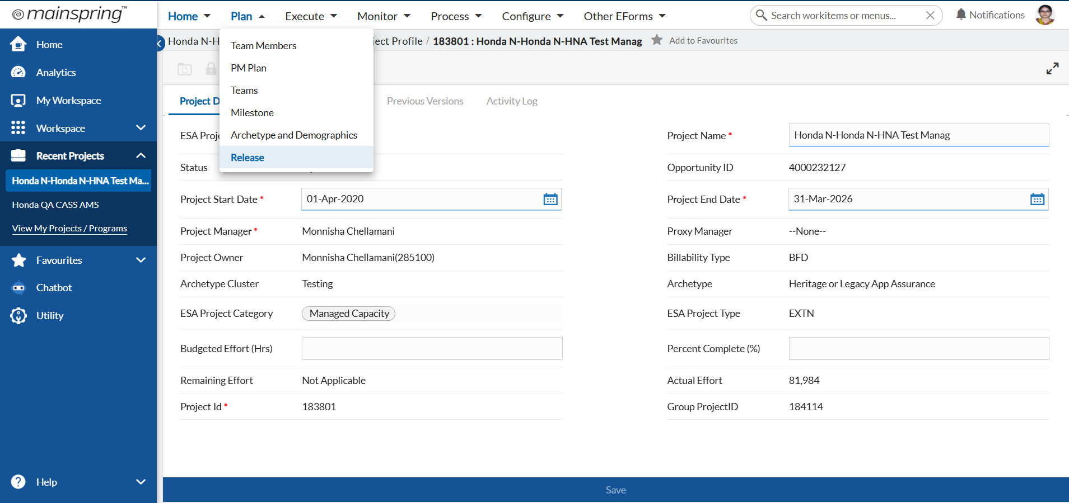

Select the current Release

Select all Critical Practices and Submit

Save it

Select and check the certify box and Save for Tools & Accelerators

Provide Valid Inputs in Measure Input

Metrics Preview – Everything should be green and within 50% of Goal Value

Close the Workpackages associated with the Release

Select Open Workpackage

Select Linked Tasks and close the task

Click TSK1

Click Close Task at the bottom

Similarly close the other TSK

Overall status should be closed

Go to Details tab

Click Completed

**Second Activity**

**Complete the Release**

**Once Work package is completed, wait for a day and then complete the release**

**Change the status to Completed and Save**

**Third Activity**

**Create a new Release**

**Click on Add button on top right**

**Enter all the mandatory details as per previous release and save**

**Once Release is created,**

**Create a new Workpackage with new tasks**

**Click Add on top**

**Enter Necessary details**

**Assign the work package to the newly created release**

**Once Workpackage is created, add tasks**

**Under Linked Tasks tab, click Check out and add new Task**

**First Activity**

* Metric Report for the current month will be generated.

Follow the below steps for Metrics Report submission

**Month End**

Click Release ID(Here : MRP147)

There will be Submit button at the bottom

Click Submit button. It will move to Prasad’s approval.

**Next Month Beginning**

**Complete the Critical Practices**

**Click on Methods Implementation**

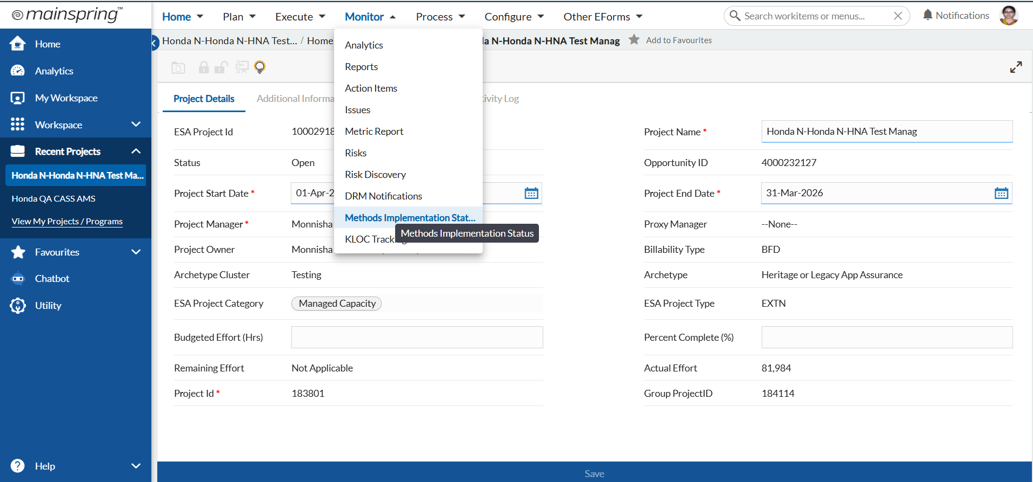

**Complete the below Affirmation and Submit**

**Note : It is a Monthly activity. At any point of time, this status should be completed.**